**Name: Zakwan Abid**

**Date: 28 Dec 2020**

**Blockchain Section A**

**Create Collection cmd:**

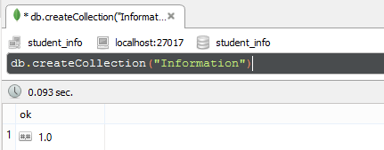

**Insert into DB:**

Inserts one or more documents.

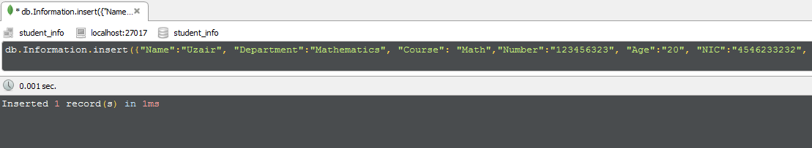

**Find cmd:**

Selects documents in a collection or a view.

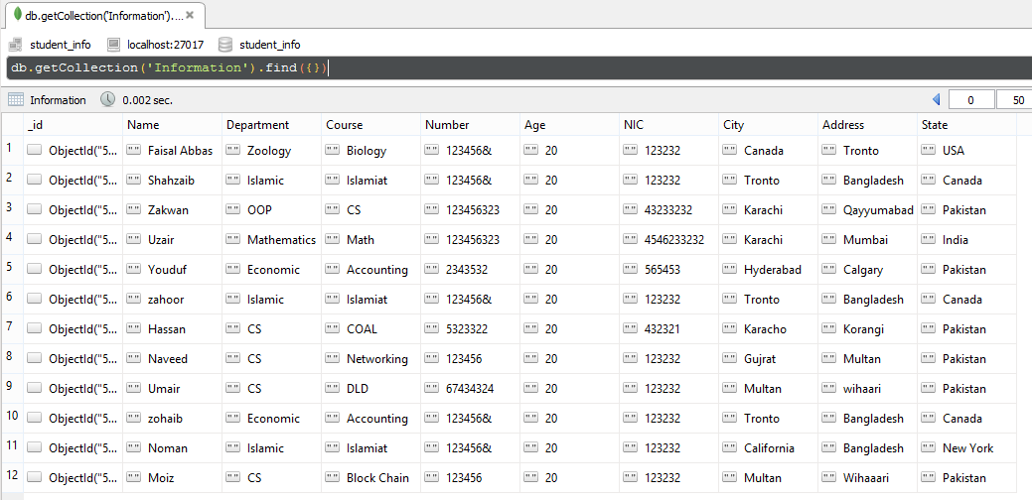

**Finding Specific Fields:**

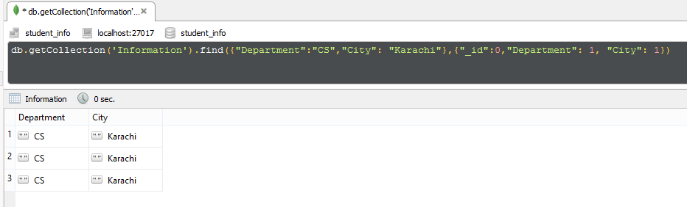

**Remove cmd:**

To remove the documents that match a deletion criteria

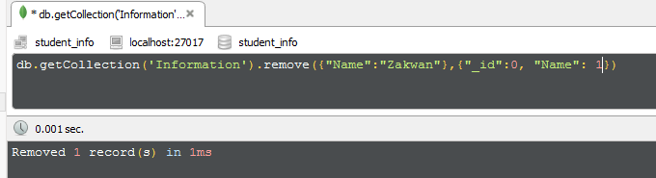

**Show all Database:**

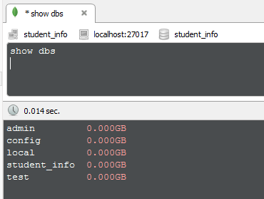

**Show Collection:**

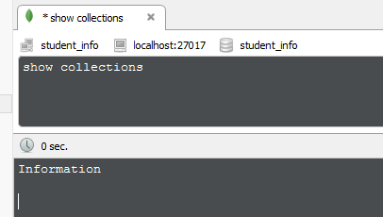

**Delete All Documents that Match a Condition**

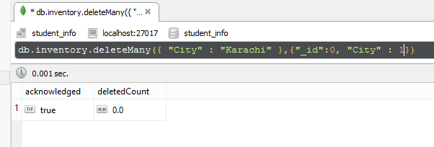

**Delete MongoDB Collection:**

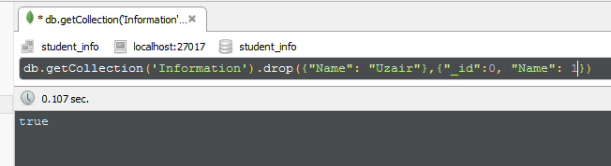

**Update Data:**

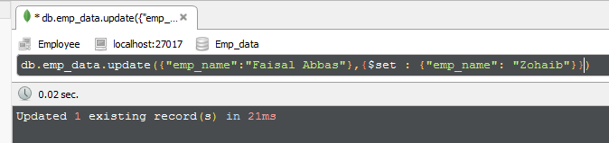

**AND (less then)Query:**

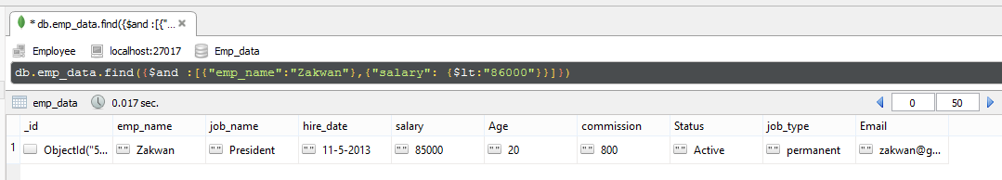

**OR Query:**

